**Task 1**

**1. Task Description :**

Implement protected routes that require authentication to access.

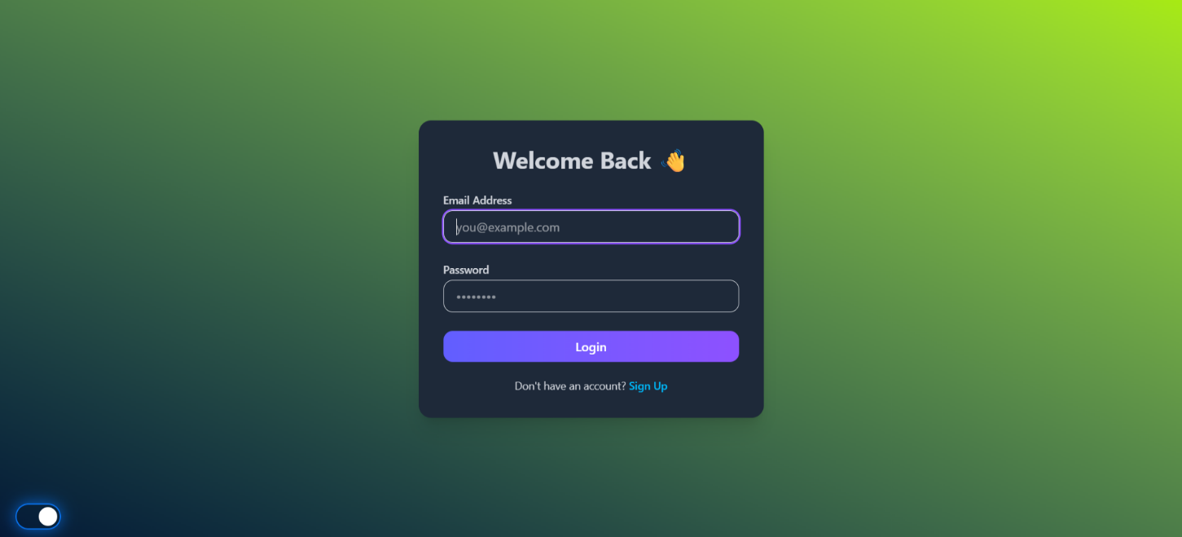**2. Screenshots :**

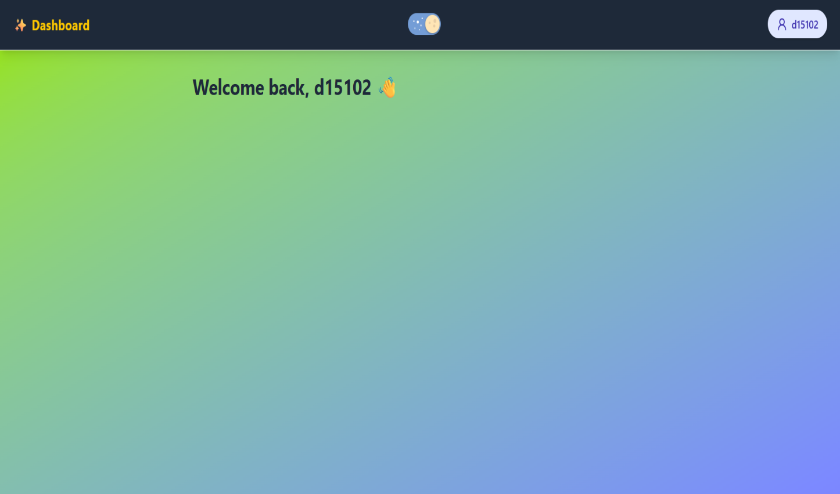

**3. Widgets/Algorithms Used in Task :**

* For APIs and Server Handling : - Node.js + Express
* For Database Management :- MongoDB Atlas
* For Frontend Framework :- React.js
* For Styling And Animations :- Tailwindcss and framer-motion